FACULTY EVALUATION
Programme Name: SBVP ALUMNI MASTERCLASS - SCALE Module I Online Kenya (20th April 2026 - 24th April 2026)
Session: Reflection of SEP Learning
Faculty Name: Dr. William Murithi
No. of Respondents: 21
No. of Participants: 21
Evaluation Parameter | (%) Individual Score | (%) Programme Average
Punctuality (Commencement and Completion of Sessions) | 95 | 96
How well do you understand the core concepts presented? | 88 | 90
Rate your confidence in applying the new skills learnt | 80 | 84
Degree of Faculty preparedness for the sessions | 94 | 94
Content and methodology of the program | 92 | 93
Quality of class and group discussions | 89 | 90
The information presented in the course is relevant to my work (ministry) | 95 | 93
Average scores | 90 | 91

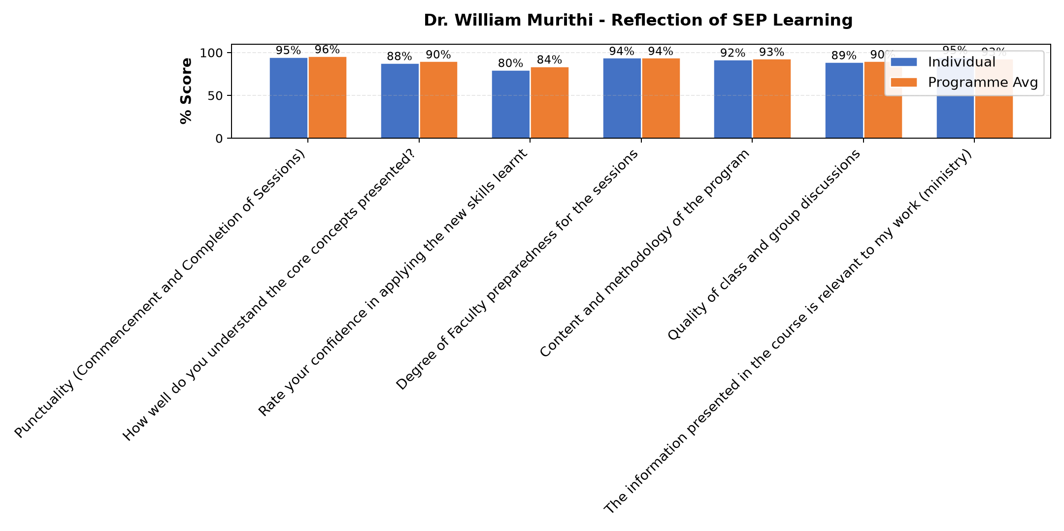

Comments & Feedback
- • The challenges that I might encounter in our social enterprise.
- • Finance
- • Lack of support systems
- • Limitation of time.
- • Distance
- • Lack of experience
- • Financial crisis
- • Financial resources
- • Resources
- • Financiall constraints
- • Financial constraints, when sharing the ideas to the other congregational members, not easy to accept change. Especially in the area of looking for other Financial streams
- • Lack of resources
- • The challenge of lack of enough finances remains a challenge to achieve my dream
- • Limited resources financially and Government regulations
- • The network barrier
- • Lack of support and inadequate finances
SUBMITTED THROUGH:
SBS Evaluation Automation System

